**APPAFIA PAYMENT FLOW EXPLANATION:**

**1-** Doctor Calendar page, Doctor can able to set the consultation fee Ex: Doctor updated consultation fee as € 200

**2-** In admin panel admin can set site charges and tax in following pages

Site charges link: <https://services.hitasoft.in/appafia/Appafia@2024/admin/sitecharge/index>

Tax Link: <https://services.hitasoft.in/appafia/Appafia@2024/admin/tax/index>

**Ex:** Admin set site charge 10% ( site charge percentage will change based on doctor fee) and Tax: 5% (Tax percentage will change based on patient country)

**3-** On the patient side, doctor fee amount will be displayed based on patient currency, patient set “EUR” currency in settings page then price will be updated in EUR currency.

**4-** Patient after complete the payment that amount will transfer to admin YekPay account and that page below mentioned.

Yekpay Account Details page: <https://services.hitasoft.in/appafia/Appafia@2024/yekpaysettings>

**5-** Once the appointment created in booking page, also message page log will be updated, so patient can chat with doctor instantly in message section, cancel button will be available for patient and doctor until checkin in time.

**6-** In admin panel, Yekpay Booking log updated in this page <https://services.hitasoft.in/appafia/Appafia@2024/admin/orders/yekpendingpayment>

**7-** In that "Yekpay Pending Payment History" page it will show the (Patient Name, Doctor Name, Status, user paid amount, Admin amount, doctor amount).

**8-** Initially the "Approve" button was in disable status because that booking was not completed, once the booking was completed means that "Approve" button changed to active status automatically.

**9-** So admin can verify the user paid amount, doctor amount, admin amount from that page. Once admin click the approve button it open the Yekpay payment page. On that page admin enter the details and click the pay button means that doctor amount settles to the doctor added Yekpay account.

**10-** If a patient cancel the appointment or doctor declined the appointment after that also update in this page "<https://services.hitasoft.in/appafia/Appafia@2024/admin/orders/yekpendingpayment> " with status "cancelled or declined" with approve button.

**11-** Admin once click the approve button it will send the refund amount to the patient on that user added Yekpay account.

**12-** If patient or doctor has not added the Yekpay payment details it will show the notify button, admin click the notify button it will send the notification to that doctor or patient to add the Yekpay payment details.

**Note:** Below we have explained the payment flow, that flow will apply for both Stripe and YekPay payment gateway.

Normal success payment flow:

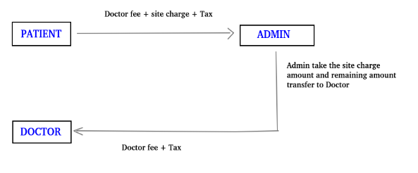

**13-** Suppose doctor canceled or day off the booking means following flow working in site

Doctor cancel the booking:

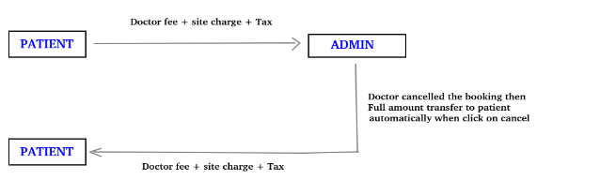

User cancel the amount during cancellation policy timing period

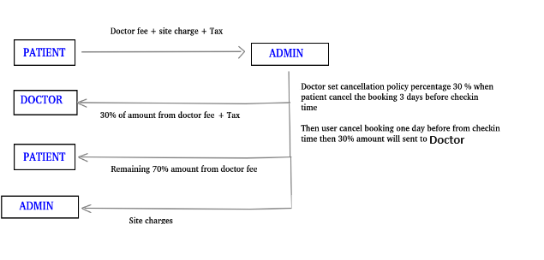

User cancel the booking before cancellation policy time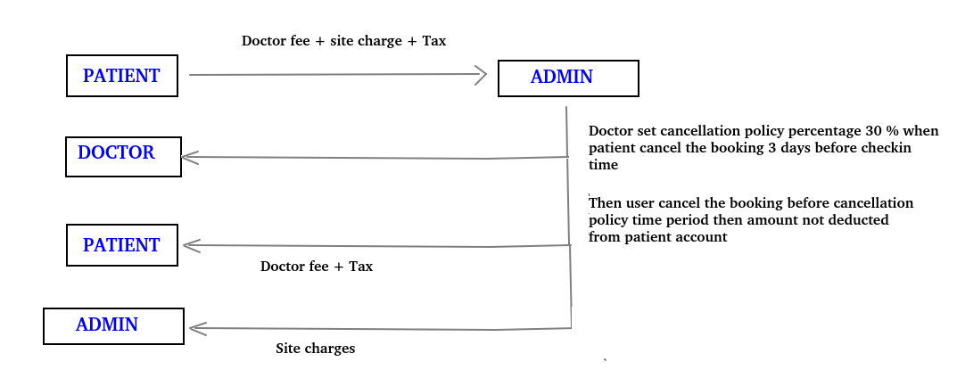

**-----Thank You-----**