**HTS-QAT021**

***SCOPE OF WORK***

*Scope of work will be mainly used to know more about the project requirements and the project details*

Project Name: **Ameer Borkaai - Pixapop**

Client Name: **Borkaai - Mr Ameer Borkaai**

Platform:  **Web (admin panel) and Android app**



**Ameer Borkaai - Pixapop**

In this phase, we have done some major functionality as a signup page called fans users and talent users, in the concept talent users join the competition with another talent user and admin also handle this competition and wallet withdrawal function for the talent users. Then we need to make some changes in the Home page,profile and activity pages, that all details are explained below.



**DISCLAIMER**

Hitasoft Technology Solutions Pvt., Ltd. has prepared this Scope of Work (SOW) document in accordance with your business requirements. It is crystal clear with accurate details related to your project.

The project will be delivered to you without any flaws according to this SOW. We (Hitasoft team) will carry out the customization work completely depending on this SOW.

The outcome of the project will be totally based on this SOW. We will complete the custom work mentioned in this comprehensive SOW document

Any other changes or inclusions of new features and functionalities during the development and after the completion of this SOW is not possible. All the other functions will work as per the base product.

We request you to review this document fully before signing as the end-product will be wholly based on this SOW.



**CONTENTS**

1. SIGNUP PAGES FOR FANS AND TALENT USERS

2. MUSIC PLAY OPTION & TEXT STATUS UPDATE & TALENT PROFILE VERIFICATION

3. FANS USERS PROFILE FUNCTIONALITY

4. WALLET FUNCTION

5. COMPETITIONS

6. LIVE PAGE AND TRENDING PAGE

7. HOME, PROFILE AND ACTIVITY PAGE CHANGES

8. ADMIN PANEL CHANGES

i - Event settings

ii - Talent user management

iii - Premium plan

iv - Wallet management

v - Competition management

vi - Verified icon



**UI DESIGN**

⇒ Here attached the customization designs in the dropbox link below. Kindly check the SOW with these designs and update us.

**Design Link :**

**<https://www.dropbox.com/sh/2dexctl2n0i44xa/AACWgMgr2ulva7bjuCdBeGUAa?dl=0>**



**1. SIGNUP PAGES FOR FANS AND TALENT USERS:**

* In this project, we need to make a separate signup and login for Talent users and Fan users.
* Here in the signup page, users click the fans option and need to show the fans signup details, if users select the talent signup need to show the talent signup details.

**FAN USER:**

* For **Fan User**, signup page we need to get some basic information only.
* Full Name
* Username
* Email ID
* Password and confirmation password.
* Country ( managed list from admin panel)
* Gender
* DOB
* Phone number
* The name field needs to set 30 characters as the maximum limit, then gender needs to show a radio button for that, and the phone number field needs to allow only numbers and as usual firebase otp validation needed.
* The DOB needs to show the date format to select the date.
* For the email id field as usual email validation formation needed.
* For county selection, we need to show all country in dropdown selection, those countries are managed in the admin panel. In this country users should select only one, same country will be updated in edit profile page.
* After signup an account it will show all active talent user profile information ( already we are showing all users in pixapop, here need to show only active talent user list)
* So if click on follow then it will show home page, followers posted post and status will be updated in the home page
* Fan user can’t able to “Add status & post, add challenge & competition” , so should not show this add option here
* Edit profile page, need to show all information which is fetched during signup process

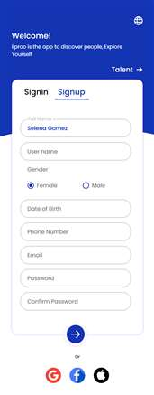 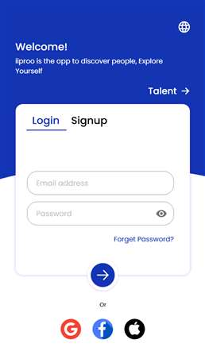

**TALENT SIGN UP:**

* Here for the **Talent User**, We need to get the following information during signup.
* Upload profile Image
* youtube link to to show us your talent (Optional field)
* User Name
* Full Name
* Email ID
* Category (Talent user needs to select any one from this category)
* Password and confirmation password.
* Country ( managed list from admin panel)
* Gender
* Date of Birth
* Phone number
* Upload profile image field, need to support JPEG and maximum 5mb image.
* Youtube link field is text field and that field should be optional.
* For user name, full name fields need to set 30 characters as maximum limit. Then the gender needs to show a radio button for that.
* The DOB needs to show the date format to select the date. For the email id field as usual email validation formation needed.
* For category and county selection, we need to show all categories and country in dropdown selection, those categories and countries are managed in the admin panel. In this category and country talent users should select only one.
* For the password and confirm password files maximum 15 char and as usual validation needed.
* Talent users fill all the information in the signup page and click the signup button then an account will be created and it goes to the pending status in the admin panel. Then it will show the people nearby list, here it will show all talent user information, click on follow then it will added in our followings page and based on the followers homepage data will be updated
* After selecting the user it will redirect to the home page, here the account is in pending status, in this time talent users try to do any status, post or do any challenges, we need to show the alert “**Your account is created and we'll review it, Thank you**”.
* In the admin panel pending tab, admin activates that talent account we need to send the email for that talent user registered email id. “**Your account has been approved and now you can access app features**”.
* After admin approval users login to the account we need to show the premium plans popup. On that premium plan need to show the free premium plan as first with Free Trial days for the newly signup talent users account. (The free trial days plan managed from the admin panel). Here the user selects the free plan and we need to show the “**Click to subscribe**” button. Users click that button that free plan activates to that user.
* EG: Admin set 3 days means we need to show that plan package in the premium plans popup for new signup talent users only. So use subscribe the free plan they get 3 days free premium plans and be able to do the challenge and access the full app.
* Once the free trial days are expired means we need to restrict that talent user account to access the POST STATUS & DO POST & CHALLENGE option. So users should purchase the premium plan within 7 days. ( Those 7 days are managed by code).
* If a user did not purchase the premium plan within 7 days that user's posts (image, videos, text), Status all are should be deleted automatically. Even if that user try to post status or Do post or challenge we need to show the alert **“Please subscribe to activate your account”** premium popup **without the free pack** with skip button.
* Users once click on skip then popup should close, suppose user purchases any one plan within 7 days and activated means that talented users can post status, post, participate in competition and no need to delete the existing posts (image, videos, text), Status.
* Premium plans managed from the admin panel. The plans page needs to show the plan name, description, days and price details with a “**pay** and **skip**” button.
* Talent Users should purchase the premium plan to access the POST STATUS & DO POST & CHALLENGE option. For this, We need to implement Stripe Payment gateway.
* Before purchasing the plan talent users try any challenge with other users we should not allow that, so on that page we need to show an alert **“Please subscribe to activate your account”** with premium plan.
* Here once the **Talent user** finishes the payment then can able to post videos, status, challenge and can participate in competition.

**Note: For the talent user post page and profile page, we need to remove the Tag user option.**

**SUBSCRIPTION EXPIRED FUNCTION:**

* New talent users sign up for an account. We need to show the premium plans popup. On that premium plan need to show the free premium or Free Trial days for the new signup talent users. (The free trial days plan managed from the admin panel). Here the user selects the free plan and we need to show the “**Click to subscribe**” button. Users click that button that free plan activates to that user.
* Talent users purchase the plan they will allow to access the challenge and post feature.
* Plan name, description, price, days information should be managed in the admin panel, so that plan expired means talent users need to renew.
* So here we need to manage the separate page for this premium plans management in talent users profile page.
* On this page we need to show the current plan name, description with start and end date, price and status “Active or Expired”.
* Once that plan expires means we need to show the expired status. So all the purchased history should be maintained on this page. In this page we need to show the “**Free Trial**” pack details also.
* For the free trial pack, here we need to show this pack name, free days and start and end days and “Active or Expired” should be shown.
* Once the free trial plan expires means we need to show the premium plan without the free plan, so users next time should purchase the paid premium plans only.
* Then the user purchases the paid premium plan for 20 days, here the plan expires. Now the plan duration will expired, we need to give 7 days as additional to this account. During this time talent user should purchase premium plan again, otherwise after 7 days talent user can’t post status, post, challenge and competition, so when click on post or challenge button it will show alert text to renew your premium plan
* Plan expired then need to sent notification and push notification to concern user to activate the plan
* Additional (7) days are managed in the admin panel. So admin can change those additional days that should be reflected for new users.
* In plan expired status we need to show the renew button. Users once click the renew button need to show the plans popup page with pay button.
* Once a user renews the plan we need to show the new plan in that premium plan page and old plan update below the new plan with expired status.
* And we need to show the admin managed additional days on this page when the active plan expired. Otherwise no need to show that additional plan days.

**NOTE: We need to show the currency symbol near the amount. That currency is managed in the admin panel.**

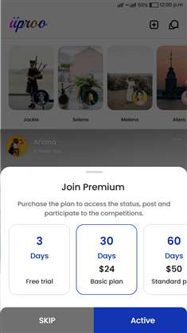 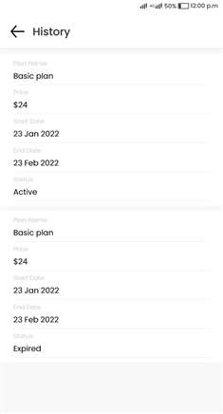

**EDIT PROFILE AND OWN PROFILE FOR TALENT USERS:**

In **edit profile page**, need to show all information which is fetched in signup page, additionally we need to show two options

1. Audio upload Enable / Disable : If enabled then it will show music file upload option, if upload audio then it will be saved, if someone view our profile then this audio will be played , if disable this audio then audio should not play when others view my profile, also need to give to upload new audio option, so we can change at any time
2. Payment configuration : If clicked then need to redirect stripe key add page, here need to fetch public key and private key, if fan user send amount then admin will transfer amount to this account except commission

Following details needed which is fetched from signup:

* Upload profile Image => Edit option needed
* youtube link to to show us your talent (Optional field) => Edit needed
* Username => Edit option not needed
* Full Name => Edit needed
* Gender => Edit option not needed
* Date of Birth => Edit needed
* Phone Number => Edit needed
* Country ( managed list from admin panel) => Edit not needed
* Mail ID => Edit not needed
* Category (Talent user needs to select any one from this category) => Edit not needed
* Change password option needed

=> In the **Own profile page**, we need to show all information which is fetched in the signup page, additionally we need to show some few options.

**=>** We need to display the Total Win and Total Losses count in the talent user's own profile page. For this we need to add separately.

**=> Then we need to show the user added music with the play option below the profile image in own talent user profile page.**

**NOTE i: Here in the admin panel we need to manage a separate page, once a new talent account created means we need to show the Activate button in pending page, once activated it will be updated in activated page, pending account page it will maintain only pending users**

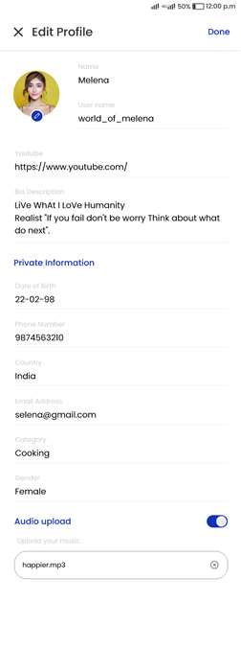



**2. MUSIC PLAY OPTION & TEXT POST & TALENT PROFILE VERIFICATION**

**TEXT POST:**

* For talent Users can Post the images and videos and story (status) images and videos as usual pixapop function will follow.
* Additionally we need to add the **text post** for talent user accounts only. So talent users post text posts like in (FB).
* For this text post we need to add a separate option in the add post page. In the add text post page we need to show the text field and background color change and font change option.
* Once a user posts a text post we need to show it on the home page as well as in the search page as usual posts. So any users can like, comment and share that text post.

**MUSIC OPTION:**

* Fans and other talent users view any one talent user's profile. We need to play the profile audio automatically. Here we Make an animation once the song is playing. When the visitor enters the talent profile.
* For this we need to get a 15 seconds audio from that talent user. Here we need to show an option as audio on and off.
* Talent A user enabled audio play in own profile, during this time some one ( Fan or Talent) user viewing the Talent A profile then need to play the audio automatically
* Other profile page need to give option to other users to disable this audio play option Ex: Talent user or Fan user viewing Talent A profile then need to show “Music” text with enable option and audio should play in background, suppose fan user disabled music for talent A profile then again fan user view this profile it should not play this music, but fan user viewing talent B profile talent b profile music should play correctly, so Enable option needed for every talent profile
* Here talent users on the profile audio, then other users view that profile, first we need to play that audio and then show the profile information. If off means directly show the profile information without audio.

**VERIFY USER PROFILE:**

* We need to show the "Verified Icon" near the Talents users name to show this is a verified talent profile.
* For this verified icon, once the talent user account was created and that account approved by admin means we need to show the verified icon on the profile page. If a fan user upgrades the talent account also the same process will be handled.
* So we have to show this verified icon on profile page in all pages and other fans and talent users.
* In the admin panel, admin views that talent user profile page we need to show that talented users challenge, videos, post and follow/following count and verified user identification also.



**3. FANS USERS PROFILE FUNCTIONALITY:**

* Fan Users can view the Talent user’s text post, Videos, images and Event (Competitions) only. They can’t join this.
* Fans users are unable to make a post and stories, so can’t post anything just following talent users and Commenting on talent’s posts and Reply to other fan users and like their comments and replies.
* So fans user profile page we need to show the “**All posts”** and “**link”** tabs instead of all posts and tagged post tabs.
* In the **All posts** page we need to show the shared posts (images, videos , text post and competitions), which were shared by that fan user. Both internal and external shared posts should be shown on the fans All Posts page.
* In the **link** tab we need to show the social media url like, fb, twitter, whatsapp.. Etc. Those links are managed in the admin panel. When click on this link need to redirect concern page
* If a fan user followed any talent users, here that talent user made a competition we need to receive the push notification for that.
* If Fan User wants to upgrade the account to Talent User, They can do this.
* For this we need to add a “**Upgrade to Talent**” button in the profile page. User clicks that button and we need to get some details from these users.
* We need to get the profile image,profile audio, youtube link to show us your talent (Optional field), category,country selection option.
* Once they enter all the details and click the **save** button, here we need to show the alert “**Your request has been received, we’ll review it to see if you are meeting our requirements, Thank you.**” and it goes to the pending status in the admin panel. Once the admin approves the request we need to send email for that user registered email id. “**Your account has been approved and now you can access app features**”.
* Once the admin approves then user login to the account, here we need to show the premium purchase plans with free trial plan, so once users subscribe the free plan can able to access the full app feature then as usual talent users functionality will be applied and they can make a challenge to other talent users.
* Then Setting page stripe and profile page music upload option will be enabled.

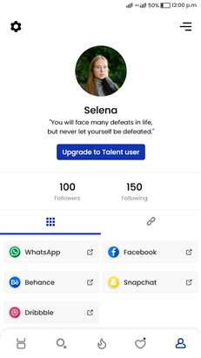 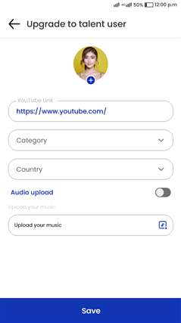



**4. WALLET FUNCTION:**

* We need to implement the wallet function in this project. Here **fan users** view any one talent user profile we need to show the “**Send Money**” button.
* Fan users click the button we need to redirect the money transfer page.
* In that page we need to get the amount field, card number, expired date and cvv number with the “**Send money**” and **cancel** button.
* Users enter all the details and click the “**Send Money**” button that amounts first to transfer to the admin added stripe account. Here we need to show the alert “**Money sent successfully and thanks for your support**”.
* Users click the **cancel** button and we need to show the previous page.
* After sending the money we need to manage that transaction history in a separate page in the profile page.
* On that **transaction history** page we need to manage the amount, talent username, date and time and amount.
* Once a user sends the money that is directly received to the admin account. Here we need to manage that amount in the admin panel.
* At the same time we need to show the **amount received notification** to the particular **talent user** with the amount sended username.
* For this we need to manage the separate page in the talent user profile page as “**Received Money**”.
* In this page we need to show the amount **(Admin deducted balance amount)**, sended username, date and time.
* On that page we need to show the total amount with the **request button**.
* When a Talent user sends the **withdrawal request**, Request will be updated on the admin panel.
* So the admin will send the 70% amount to the talent user stripe account from the admin panel. (Here the percentage amount managed in the admin panel. Admin can change that percentage it will reflect new users).

**EG: user send 100 rs to the talent user, that amount first update to the admin panel. Here the admin deducted 30% of the amount and sent 70 rs to the talent user stripe account. That percentage is managed in the admin panel.**

* Here talent users did not add the stripe details we need to show the alert and redirect to the stripe account details page.
* Commission percentage deducted for each transaction which is send by fan user
* Ex: fan A sending 100, then 70 $ updated for talent A account, Fan b sending 100 then another 70$ only updated in talent account so talent user can withdraw only 140 $.
* We need to manage the minimum transaction amount in the admin panel. So fan users send the amount below the admin managed amount needed to show the alert. **“**Minimum transaction amount is 10$ so kindly send above 10$**”.**
* Here admin can change the minimum transaction amount, once admin change means that it reflects on the next transaction.

**NOTE: We need to manage the currency for the transaction so need to show the currency symbol near the amount. That currency is managed in admin panel.**

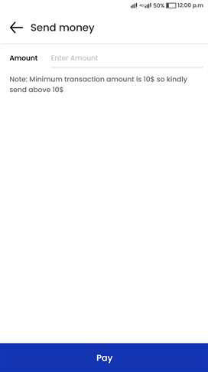 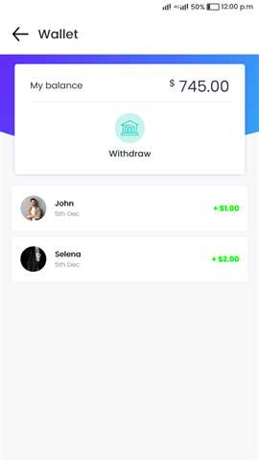



**5. COMPETITIONS:**

* It’s for the Talent user only. If a Talent user will see the other Talent user’s profile, We need to show the “**Challenge**” button.
* Here both talent users are in the same category means we need to show the “**Challenge**” button.
* EG: User A selects the dance category, but user B selects the singing category. We do not need to show the challenge button.
* Once both users are in the same category we need to show the challenge button.
* We need to implement 3 types of Competition

**• One to One competition**

**• Local competition**

**• Global competition**

**i - One to One Competition**

* It’s a friendly competition. If both users are in the **same category** we need to show the challenge button in the user profile page.
* Here user A clicks the **challenge button**, we need to send the notification to that user B with **accept** button
* User B needs to respond to it, if the user did not respond to it, after 24 hours that notification accept button will be removed and it will show expired status for user B, and user A gets a notification with “**User B abandoned your challenge**”.
* EG: User A sent a challenge request on 1:00 AM on 7/3/2022 that notification should be in active status for 8/3/2022 1:00 AM. After completing this time the user was not accepted then notification sent to the requested user “**User B abandoned your challenge**” in user A notification page.
* If User B accepted the challenge, then it will show a **post video button** for user B and requested user A also get notification and push notification, in the notification page need to show **challenge accepted**  “**post video”** button. Here we need to **disable** the post video button for 10 min and we need to show the challenge starts in 10 mins on that same notification. ( 10 mins duration will be controlled by Admin from Admin panel)
* So after the end of the 10 min we need to send the push notification to the users “ **Your Challenge started, now you can post the video**” and **enable** the **post video button**, so both users have posted the competition video. After posted the video, the competition voting will be started so During this 24 hours timing we have to post video and get voting from fans to announce winner (24 hrs are managed in admin panel)

**EG:** User A sent a challenge request to user B, user B accepted the challenge so notification should be updated for both users on 1:00 AM on 26/4/2022. After the 10 mins challenge started, so it started at 1.10AM. If admin set 24 hours means that challenge voting time will end on 27/4/2022 1:10 AM ( so inbetween 24 hours time both user should post video, so once posted it will merge and it will update to all fan users, so voting will be started . After completing 24 hrs we need to verify the voting count.

* So for users clicking the **post video button** we need to show the **record screen** page, in the record page we need to show the camera front and back rotate option and flash on/off option.
* Here we need to add a gallery upload option. So talent users have added a video from gallery also for this we need to add a trim option in the upload page. So users can trim the video maximum 30 seconds and minimum 10 seconds. (this for all competition page)
* So once the user clicks the **record button** we need to record that video for a maximum of 30 seconds and minimum 10 seconds only.

( maximum and minimum seconds managed by code).

* Once user B and user A posted the video, We need to merge that video and post it automatically to both talents profiles, so fan users page it will be updated
* So, the following Fans and talent users can see this video. So Fan and talent users can view both users' challenges and vote for these videos. For this voting we need to set the time EG: 24 hours, That time was managed in the admin panel. Talent user can view the other talent user challenge but can’t vote, fan user only can vote ..
* At the End time of Event, Who will get more votes that user will be Winner and announced for the all followed fans and talent users in notification page and below that videos with vote count. And notification needed for the winner user notification page.
* If user A did not post the video means user B will announce the winner when user B posted the video. If both users did not post the video means both users did not get any points. One to one competition both have same votes then we have to announce winner based on winning point, winning point same then we have to show based on losing count
* For this one to one competition winner, we need to give 1 point for the winners and this count should be updated in profile page and also we need to update the total loss point in users profile page and admin panel.
* Here the winner will get 1 point and the loser will lose 1 point from the 1 on 1 challenge. We rank people who will go to the local challenges based on the winning count , we will take the first 32 talents users on point ranking, the first 32 users will be able to join the local challenges.
* The ranking will be by the points based on the talent users win and loses, so if user A is in the 32 place with 123 points and user B with 122 and win another 1 point, here we have to see the history of both users the one with more wins will be in the 32 place. If both have the same number of wins.
* In This situation we'll see which user has few losses, for this we need to check both user's losses history and then we will give the 32 place to that few losses users.

**NOTE i: For the competition we need to manage the details in the admin panel. On that page we need to show the user A and B name, challenge video and winner and point.**

**ii- Local Competition**

* Admin will handle this Event. It’s the Local Country Event. Admin will post this **Event based on the countries and categories**.
* For this we need to add a new page in the admin panel called “Competition management”.
* Here admin select the country and category and start and end date.

**EG: Admin select the US country and Dance category and set the start and end date.**

* In US countries talent users who are in the dance category, those talent users only get the notification for this local competition with start date and end date in the notification page.
* Us country dance category has 300 users, then we need to take the 32 users from this list based on the one to one competition winning point. First-round will start, after the first round, 16 will be out(losers), and 16 will stay in(winners).
* So second round conducted based on 16 winners of first round, third round 8 members of winners fourth round will be 4 members fight round will be 2 members, so after fifth round winner will be announced for this competition , suppose 32 users not there in this category we have to take 16 users, suppose only 7 users are there then need to set round only for first 4 members , so we have to set round based on the users count.
* This competition has 5 rounds and is based on the members' count. For the first round we select the 32 members, that members selection based on the one to one competition winning points.

**EG: User A has 30 points and user B has 23 points, but user C has 29 points means we select user A and user C for the local event. So this local competition connection is based on the one to one event points. So we have to take users list based on the winning point and conduct event based on this**

* Admin added local event then user get notification like “ local event will start at “date” between “user A” and you, when click on this user A name need to redirect user A profile, so once started date reached we need to send the push notification to the users with competition started with “post video” button, button will be available 24 hours, so user should post the video before this time, both users are posted video then it will updated to fan users of this talent users, so fan user should vote before this 24 hours, once 24 hours end then system will calculate winners based on this vote
* Once the first round finishes, The second round will be started for the Winners of the first round. For the second round we select 16 members, that members selection based on the first round winners based on the votes, so we have to send notification to first round winners like “Congrats, you won first round, second round will be started “date”’ between “user C” and you” so after 24 hours second round will be started automatically and challenge button will be enabled, so users have to upload video before this time and after complete 24 hours system will calculate votes
* Then the third round will be started after 24 hours between 8 winners of second round, that members selection based on the second round winners based on the votes. Same process will be continued until select one winner
* Then the fourth round has 4 members, that members selection based on the third round winners based on the votes.
* Here the final fifth round has 2 members, Those 2 members are selected based on the fourth round winner.
* And finally in the fifth round winner as a local competition winner based on the votes.

**Note: Each round duration and competition duration will be managed from admin panel.**

* Now user A and B received the local competition notification and both are posted video, here need to merge that video and post it automatically to both talent profiles and that challenge shown in the live page, That manage separately.
* So, Who will get more votes, that user will be Winner and winner get notification for second round
* But Here user A and B received the local competition notification form admin. **Here both users not accept that challenge** after the round ends we announce the winners users for the next round except this users.

EG: The first round has 32 members, here 2 users does not accept the competition, so the competition runs with 30 users only. Finally we will announce 15 members as winners and move to the second round. So second round will be conducted for 14 members, 1 member will be directly moved to third round ( we have select this member based on first round high vote count) **(This function will be followed as all rounds if both users did not accept the challenge).**

* Then user A accepts the challenge but **user B does not accept that challenge**, after the end of the round we need to announce user A as winner and move to the next round. **(This function will be followed as all rounds if any one user did not accept the challenge).**
* Then user A and B accept the challenge and post videos. **Here that video does not get any votes** at the end of the challenge we need to verify that users vote in one to one competition. In that one to one competition, which user gets the most votes will be announced as the winner and move to the next round. **(This function will be followed as all rounds if the video did not get any votes in this challenge).**
* So all rounds competition members and round winners need to be managed in the admin panel.
* After that, Final round will finish and Winner is qualified to join the Global Event. When we start a global event the winners will get a notification.

**NOTE i: For each and every round the user needs to make the separate videos for the competitions.**

**iii- Global competition**

* This competition is also handled by admin. This event is for the Local competition winners users only. **Here admin will post this Event based on the local competition winners** which are from the country and category.
* For this global competition admin will set the start and end date only because local competition winners are already selected based on the country and category.
* Once Admin posted this Event, The Talent User who is the winner of a local competition based on Dance Category will receive the notification.
* Once they accept it, events will be started between these people. These users need to post the video during the event time. After that, We need to merge the videos of 2 users and post it for the competition.
* Rounds will happen as like Local Events. Finally, There will be the Winner for this over all competition and announce it to all users.
* Here we will use the same local competition functionality for this global competition, no changes needed here.



**6. LIVE PAGE AND TRENDING PAGE:**

**LIVE PAGE:**

* In the competition video we need to show the **fire icon** is for the explorer.
* Once users click it will take them to the new page, that page below attached.

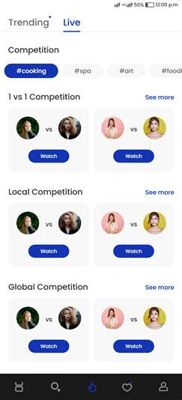

* By default it will show the trending tab first, then users can go to Live manually.
* In this live page, We need to show all the Events of that user’s followers. We will show the event separately based on each and every category.
* We will show the event separately based on **One to One**, **Local Event** and **Global Event**, if the user will click the Watch option, We need to show the below attached page.
* In between the videos we need to show the black bar, in the black bar we need to show the vote remaining timing (Voting time added by admin) so we will reduce the time in the black bar and need to show total watching count.

EG: 30 min is voting time means we need to reduce the time and show in the black bar.

* Once the challenge is going on we need the comments section to show once the user swaps from down to up. So they can watch comments and reply at the same time.

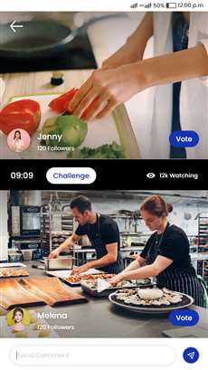

* We need to merge both Talent user’s videos and show it like this. Users can play anyone before the vote Once you play the top video, the bottom video will stop. And vice-versa.
* Fan Users can vote for any one video only. On this page, We need to have the “Comment” option.
* And we need to show the play/pause option and remaining time with watching count with a vote button.
* **Need to show the vote button for fans users only. For talent users no need to show the vote and comment option.**
* Here any one fan user clicking the vote button needs to change that button to “voted” and hide the vote button for other video

**TRENDING PAGE:**

* In this trending page, we need to show talent users videos which was posted from the normal post option. No need to show the challenges videos in this trending page.
* So in this page we need to have the Trending page like below attached image.
* In this page, We need to have 2 sections

**• Top Talents**

**• New Talents**

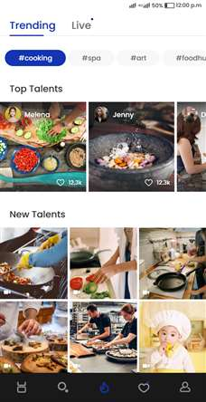

**i- Top Talent:**

* We need to show the Talent users video list of those who get more than 5000 likes to his anyone post, that should be updated every 24 hour.
* Any one user click that means need to redirect to show that user video page correctly, here we can click and view the user profile page also .
* In the header it showing the #hashtags, that hashtags are nothing but categories.
* We need to show this based on each and every category's likes, which category users get more likes that shown in first #hashtag then so on.

**ii- New Talents:**

* We need to show the Talent users list on this 0 likes and more to his anyone post. Based on video posted time, it will be updated.
* If any one user clicks that means they need to redirect to show that user video correctly.



**7. HOME, PROFILE AND ACTIVITY PAGE CHANGES:**

* We need to make the UI changes for the Mobile app on the Following pages.

**• Home Page**

**• Profile Page**

**• Activity Page**

**i- Home Page:**

* For the Home page, We need to make some attractive designs based on below.

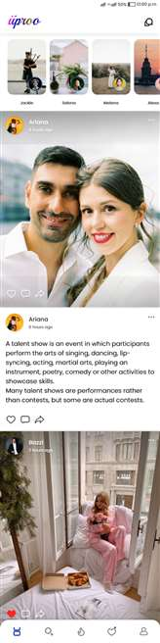

* In the home page, and search page, trending videos view page we need to run the video automatically.
* Then in the post and trending view page we need to show Username, Profile image ,Time And follow button in header and in footer we need to show the like, comment and share icons only. Other information is not needed.
* Here users single click the posts ( image or video or text) we need to open the other information on the new screen. On that screen we need to show the like count, comment count and share count and other information. On that new screen the user is able to comment and view the others' comments. User double tap the screen we need to initiate the like,

**NOTE: When User posts the Image or Video, We need to remove the Tag User option. Because, We need to remove restrictions based on Image size.**

**ii- Profile Page:**

* We need to show the Profile image as below. Based on this, We need to make the design.
* For Talent User, We need to show the **Posts** , **link** and **challenge** tabs in own profile page.
* In the **posts** tab which are posted by the talent User that posts should be updated in this page.
* Then in the **Challenge** tab need to show the user challenged videos should be updated in this **challenge** tab.
* **Link** tab need to show the link which is added from admin panel
* For Fan User, We need to show the Posts and link, post which are shared by the User.

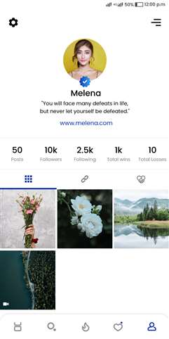

* This link page is both for fans and talent users. If User will click the “Link” icon, We need to redirect the user to the page below.
* For this, We need to show the images of Social media. We need to make the option for users to update the links for social media. Based on this, We need to show it. If User will click it, We need to redirect the user to a particular one.

**iii- Activity Page:**

* We need to make the Activity page as below.

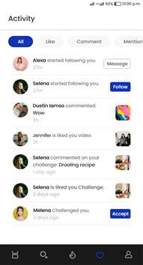

* For Talent User, We need to have 5 sections All, Like, Comment, Mention and Challenge.
* For Fan User, We need to have 4 sections All, Like, Comment, Mention.
* For Fan User, when the talents are challenged to other user the fans will get a notification in " All" we don't have to make a section for it.
* Let's say I am a fan. and I am following you and 4 more talent people. If all talents I am following are in challenge I'll get a notification for all of them and I choose who to watch.

**Note: We need to work on the above mentioned modules only. Pixapop Product’s other pages will work as usual. So, We don’t need to have any design changes and functionality changes on the other pages.**



**8. ADMIN PANEL CHANGES:**

* Need To split users as ( Fan user and talent user )
* We need to change the “**Users**” name to “**Fans user**”. Then in both the user and blocked users view page it shows the post,stories tab. Need to hide for the fans users because fans users could not post any images,videos and stories.
* Then in the admin panel we need to add a new option called **Event Settings**.

**1- EVENT SETTINGS:**

* In this Event Settings page we need to manage the “**Country**” “**Category**” “**General setting**” “**Social setting link**”.

**A - MANAGE COUNTRY**

* Below the Event settings, first we need to show this “**Manage Country**” for talent users.
* Here admin adds a country that should show in the talent user signup page.
* In the **country page** we need to show the S.NO, country name and **edit/delete** button. In that same page header needs to show the add button, once admin clicks need to redirect add country page.
* In the add country page admin enter the country name and save means need to save that.
* Here once users select any one country we need to hide the delete button and can edit the country name.

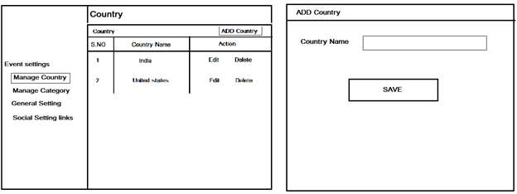

**B - MANAGE CATEGORY**

* Below the Event settings, second we need to show this **category page.** Here S.NO, category name and **delete, edit button**. In that same page header needs to show the add button, once admin clicks need to redirect add category page.
* In the add category page admin enter the category name and save means need to save that.
* Here once users select any one category we need to hide the delete button can edit the category name.

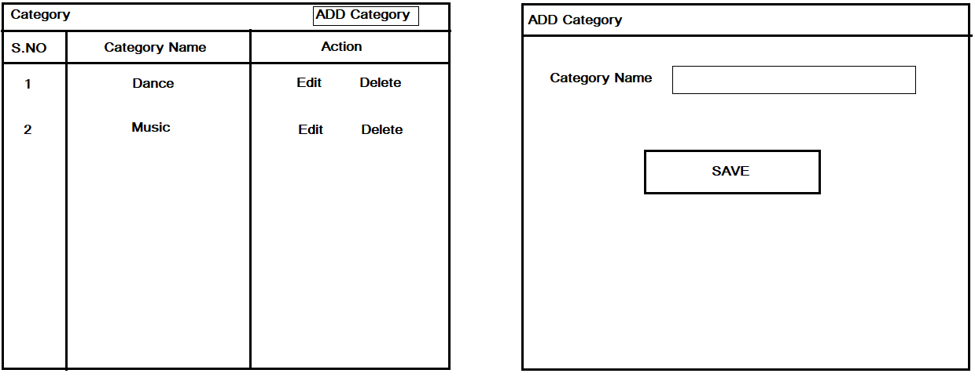

**C - GENERAL SETTING:**

* Below the Event settings, third we need to show this **general setting** page for managing the below mentioned options.

**i** **Admin commission**

**ii Additional plan free days**.

**iii 1 to 1 Challenge request timing**

**iv Vote timing**

**i Admin commission:**

* we need to manage the admin commission percentage text box and save button. Admin once enter the value and save means that should reflect when admin transfers the fans tips to talent users.

**EG: Fan user send 100 $ to the talent user, that amount first update to the admin panel. Here the admin deducted 30% of the amount and sent 70 $ to the talent user stripe account. That percentage is managed in this page.**

* Admin can change the percentage amount that reflects on the next fans user donated amount.

**ii Additional plan free days:**

* We need to manage the additional plan free days with a text box and save button. Admin once enter the days and save means that should reflect once talent user premium plan expires.

**EG: User purchase 20 days plan, here plan expired. Now the plan duration will expire, but admin given 2 days as additional days for all accounts. After that only, We need to deactivate the account.**

* Now the plan expired on the 20th day means we need to intimate that user, “**your plan expired on today so kindly renew to activate your account. Now we give 2 days additional**”.
* Admin can change those “Additional” days that should be relect for the new users and plan renewed users.

**iii 1 to 1 Challenge request timing:**

* For the one to one challenge, user A clicks the **challenge button**, we need to send the notification to that user with the accept button to user B.
* Here in user B notification “challenge” page that request showing with accept button. We need to manage the “**Accept**” button showing time in the user B notification challenge page.
* Here User B accepted, then it will show the **post video** button and requested user A also get push notification, in notification page need to show **post video** button.
* Then both users post a video for challenge and as usual the voting process will be handled.
* Here the challenge “**Accept and Post video**” buttons show times we need to manage. In the admin panel we need to manage that timing, So we need to add the **minutes** field with a save button on this page.
* Once admin set **10 mins** for the 1 to 1 competition. User A sends the challenge request to user B, **within 10 mins user B accepts the request and both user A and B posts the challenge videos.**
* If the time reached, but user B did not **Accept** that challenge we needed to show expired status for both users. And show the notification for user A, user B did not accept the challenge.
* User A or B did not **post the video** for the challenge needed to show expired status for both users. And show the notification for user A or user B did not post the challenge video.
* Admin can edit this request timing for **minutes**. That should reflect on the next 1 to 1 challenges.

**iv Vote timing:**

* For all competitions **1 to 1 , local and global** we need to manage the vote timing when talent users post challenge videos.
* Once both users posted a video then we need to calculate this time for voting.
* So for the timing we needed the **minutes** fields as editable. Admin can change the vote timing for **minutes** and **hours**.
* Once admin changes the vote timing and save means that should reflect on the next challenges.
* If the admin set **30 minutes** means that the voting poll is shown for 30 mins only for fans and talent users. This is the same as hours.
* Once the voting time is reached we need to stop the voting process and announce the results based on the votes.

**D - SOCIAL SETTING LINKS:**

* Below the Event settings, fourth we need to show this **social setting link.** In the ap**p** both fans and talent users have a link **tab** on there's profile page. On that link are managed from this admin panel.
* For that we need to add a new option as **Social media links management** in the site setting page.
* On that page we need to show **S.NO, image, name and links with the edit and delete** option and on the header we need to show the add button.
* And clicking the **edit button** we need to show that editable, admin can edit that image, name and url, if select delete option need to delete that link from admin panel and apps link tab also.
* Admin click the **add button** we need to show the add links page.
* In this page **image upload field** needed and **text field** and **link field**.
* Once admin adds a new social link that should update in the app links tab. In app users click that link that needs to be redirected correctly to the social media page.

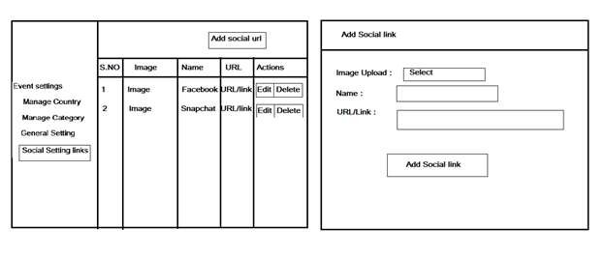

**2 - TALENT USERS MANAGEMENT:**

* Then we need to add a new option called “Talent user management”.
* In the talent user page we need to add 3 tabs.
* Pending
* Active
* Inactive or blocked
* **PENDING:**
* In apps, new talent users sign up an account initially we need to show in this pending tab.
* In this pending page we need to show the ID,username,email,**view and approve button**.
* Then in the **view page** we need to show the profile image and audio with the play button and plans purchase details and other information which is fetched during signup process
* In the plans field, user did not purchase the plan it means need to show “**Not purchased**” status, if purchased means need to show that plan name with “**Purchased**”.
* Once the admin approves we need to change that user to the “**Active**” tab.

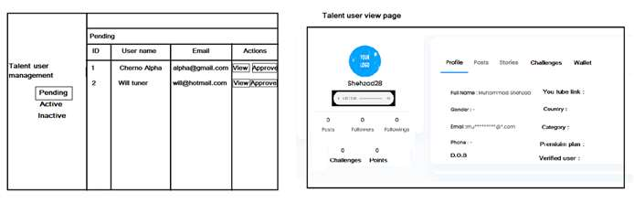

* **ACTIVE:**
* In the active page need to show the admin approved users list. Here we need to show the ID,name, email, **view and block**.
* In view page needs to show the profile image and audio, country and category, gender, mobile number, post, followers, following, stories and challenge, points (Both win and loss )and wallet.
* Here the wallet needs to show the **current wallet amount** of the user and **withdrawal amounts**. If both amounts are 0 need to show that value.
* And we need to manage the competition count in the challenge tab. If users participate the one to one competition means need to show that counts and local competition and global competition separately to show that counts, even win or loss or that the user did not join any competitions and needed to show 0. And we need to show the view option.
* Admin click the view option we need to show that challenge video with votes.
* Here admin **blocks the talent user account** that needs to show in the **Inactive tab**.

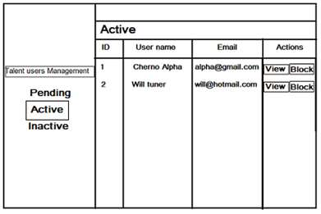

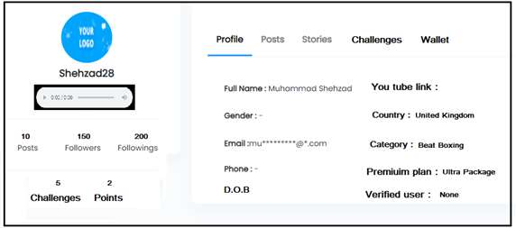

**Talent user profile view page.**

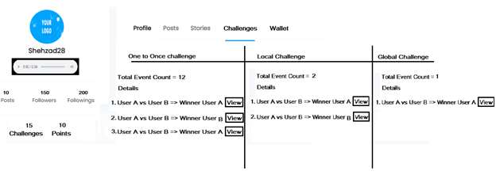

**Talent user challenges page.**

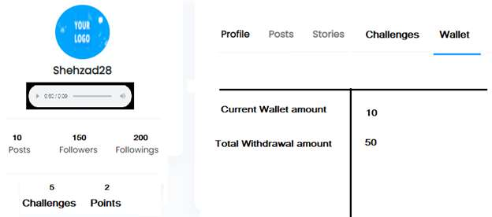

**Talent users wallet page**

* **Inactive**
* In the active tab need to show the admin approved users list. Here we need to show the ID,name, email, **view and active.**
* In view page needs to show the profile image and audio, country and category, gender, mobile number post, followers, following, stories and challenge videos, points.
* Here **admin activates the talent user account** that needs to show in the **active tab.**

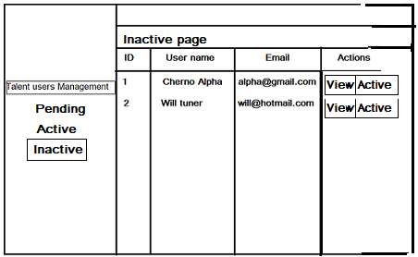

**3 - PREMIUM PLANS:**

* **Plans page:**
* In this project we need to manage the premium plans for talent users to make a competition.
* For this we need to manage the plans details, transaction history and subscription management.
* Here we need to give the free premium or Free Trial days for the new signup talent users. For this we need to add the new plan called “Free Trial” pack.
* In the add plans page admin add the plan with “0” price that plan should show in the “Free Trial” in front end and admin panel.

EG: Admin set 3 days plan new signup talent users subscribe the free premium plans and be able to do the challenge and access the full app features for 3 days

* In the **plans management** we need to show the S.No, Plan name, days with **edit/delete** buttons and header we need to show the add button for adding a new plan
* In the edit page admin can edit the name, days and price details, here once admin edit and save means that need to reflect on new users and renewal users plans page.
* Then in the header click the add button and need to redirect the add plans page.
* In the add plans page need to show the plan name, days and price, once admin save means need to redirect plans page and show the recently added plans.
* Here we need to show the currency for the transaction, So we show that currency in the plans page.

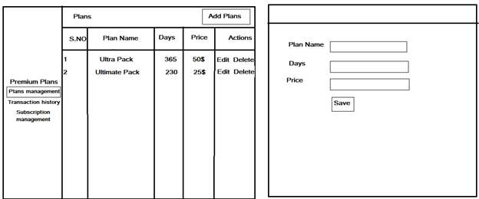

* **Transaction History:**
* In this transaction history page we need to manage the talent users' purchased log history.
* Here we need to show the S.NO, username, plan name, price, days and purchased date. When click on name need to redirect talent user view page
* **Subscription management:**
* In the subscribe users page we need to manage 2 tabs called **active and inactive**.
* In the **active tab** we need to show the plans activate users list with user name, plan name, days, price, start date and end date.
* In the **inactive tab** we need to show the plans ended users list with last purchased plan details. user name, plan name, days, price, start date and end date.

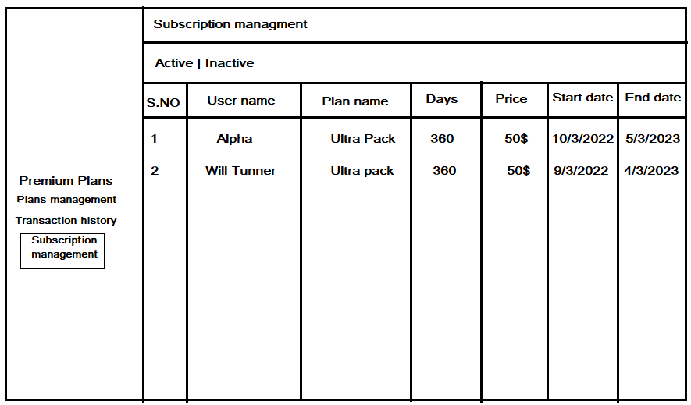

**4 - WALLET MANAGEMENT:**

* In the wallet page we need to manage 2 options as **“Invoice” and “Withdrawal”.**
* In the “**Invoice**” page we need to manage the “Fans user” donated amount to “Talent user”.
* Here on this page we need to show the S.NO, Fan name, Talent name, amount, res and Talent user amount and date. (**Admin deduction managed in general setting page**)

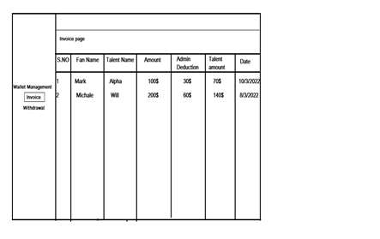

* In the “**Withdrawal**” page we need to manage the Talent user withdrawal request. And we need to show 2 tabs called “Pending” and “Approved”.
* Who has sent the money withdrawal request to the admin that requests need to show in this “Pending” tab with S.NO, talent username, amount,date,Decline and approve buttons.
* Here admin click the approve button, need to check that user if add a stripe details are not. If that user adds the stripe key, they need to move that on the approved tab and the amount credited to that requested talent user stripe account.
* Else that user did not add the stripe key or wrong stripe key means we need to show the alert “User not added the stripe key”.
* If the admin clicks the “**Declient button**” that amount should be sent to the fan user account.
* We need to manage the minimum transaction amount in the admin panel. So fan users send the amount below the admin managed amount needed to show the alert. **“Minimum transaction amount is 10$ so kindly send above 10$”.**
* Here admin can change the minimum transaction amount, once admin change means that it reflects on the next transaction.

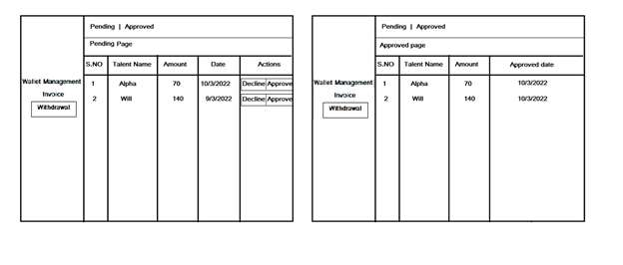

**5 - COMPETITION MANAGEMENT**

* In this page we need to manage the 3 competitions that are mentioned below.
* One to one competition
* Local competition
* Global competition

**i - One to one competition**

* Here user A clicks the **challenge button**, we need to send the notification to that user with accept button
* User accepted, then it will show post video button and requested user also get notification and push notification, in notification page need to show post video button for requested user
* Once competitions start, we need to show in “**Active**” tab. In this active tab we need to manage the ID,user A name and User B name,country ,category and start date. Here the admin clicks that username we need to redirect that user profile.
* Once competition finished after admin allocate time, it moved to the “**Completed**” tab.
* In this completed tab we need to show the ID, user A and User B name, country, category, competition date and winner and vote ,point.

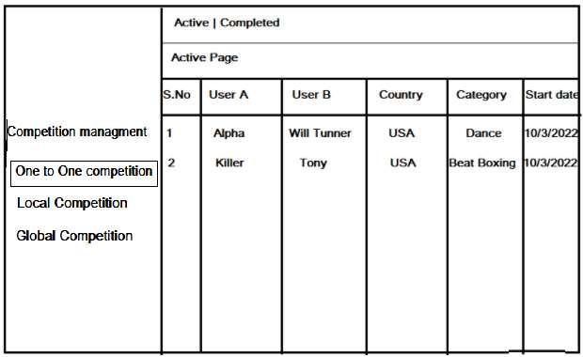

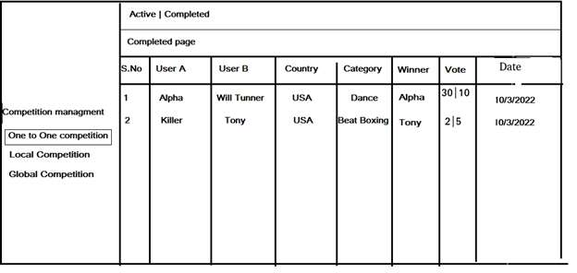

**ii - Local competition:**

* For the local competition, we need to show the event management tab inside the local competition page. In this event management tab we need to show the event name, select country and select category option. Then start date fields needed.
* For the event management we need to add the edit option for editing the country, category , date.

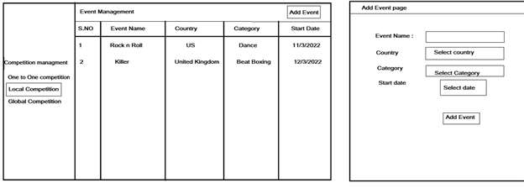

* Here once the competition date is reached means we need to hide the edit button.
* Here admin fill the details the click the save button we need to check 32 members are available for the local competition.
* Those 32 members are selected based on the one to one competition winning points. (**Refer 6th content “Local Competition” module**).
* If 32 members are not there we need to select **16 members** for the first round.
* If 16 members are not there we need to select 8 members for the first round, if 8 members are not there select 4 members, if 2 members means we select 2 members and make a competition.
* If there are less than 2 members in that country we need to show the alert “**Members are insufficient in select country or category**” alert.
* Once the admin added the local competition where 32 members are available, we need to manage that all users log list in the “Ongoing” tab at the same time we need to send the notification for selected users.
* In the “**Ongoing**” tab we need to show the S.NO, Country,category, event name, start date, round count and **view button**.event name, start date, round count and view button.
* In this page, the search option needed in this search admin can view the competition by “Country” and “Category” . Here we need to show the dropdown options for both country and category.
* Admin select country we need to show the country based result. The same select category means we need to show country based category result.
* This same filter is needed in the “Local and global competition” ongoing and completed pages.

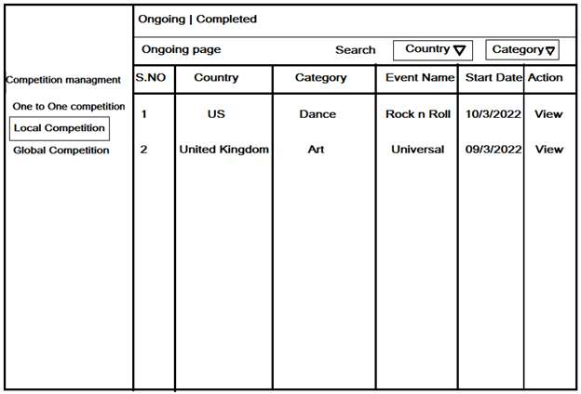

* In the **view** page we need to show the competition users log User A VS user B and status “**Ongoing**”. Here the admin clicks that username we need to redirect that user profile view page.

**EG: 32 members means 16 logs should be updated with status. This for all rounds and based on each round the members count.**

* In the status field once the competition starts need to show **ongoing**, once 24 hours are reached (**time managed in admin panel**) that round completes we show the **winner** status with the winner username for the first round.
* If both users are not participating in that competition we show the “**Not Participate**” on the status field.
* Once the first round is completed then it will announce the first round winners to the users via notification. On that notification we need to intimate the second round date.

EG: First round completed on 9/3/2022, then the second round will start after 24 hours 11/3/2022. So we need to intimate local competition participants via notification “**Username won a first round and second round will start on 11/3/2022**”.

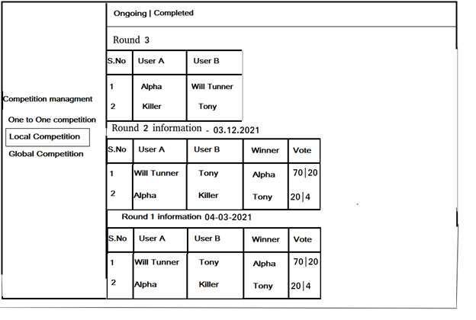

* Once first round completed means, above the first round details we need to show the second round information “user A” va “User B”
* For the second round, we need to show the competition users log User A VS user B and status “**Ongoing**”. Once the second round is completed means we need to show the third round users list above the second round. This will be updated for all rounds in the “**Local Competition => ongoing => view page**”.
* Here Admin will set the date for this local competition initially, so we need to calculate the second and continued rounds date after the round completes 24 hours.
* So the first round started on **9/3/2022 and ended 24 hours**. Here the second round or next round date should be after 24 hours from the first round completed. The next round will start on 11/3/2022. So don't need to set dates for each round, it should be calculated for next rounds automatically.
* This will be applied for all local competition rounds. And admin can add more local competitions at a time in a single country or other countries.
* But admin already added the “US” country “Dance” category means we need to restrict when admin again try to add the same category and country.
* Once the local competition's final round was finished, that competition moved to the “**Completed**” tab with that event name, country ,category and the overall round winner name.
* Winner is qualified to join the Global Event. When we start a global event the winners will get a notification.

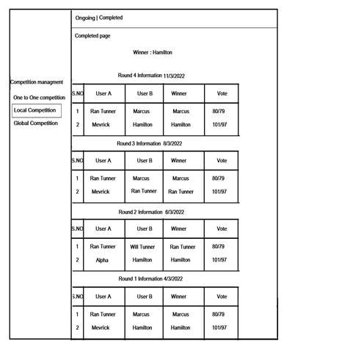

**iii - Global competition:**

* For this global competition we also need to manage the event name, country,category, start date.
* Here once the competition date is reached means we need to hide the edit button. Before the competition date we need to show the edit option.
* Rounds will happen as like Local Events. Finally, There will be the Winner for this over all competition and announce it to all users.
* Here we will use the same local competition functionality for this global competition, no changes needed here.
* In the status field once the competition starts need to show **ongoing**, once 24 hours are reached that round completes we show the **winner** status with the winner username.
* If both users are not participate on that competition we show the “**Not Participate**” on the status field.
* Once the global competition final round were finished, that competition moved to the “**Completed**” tab with that event name, country ,category and the overall round winner name.

**Note i - In the setting page we need to add the stripe public and private key fields for wallet and plans function.**

**Note ii - For the payment wallet and premium plans we need to use only one currency for the amount transaction function.**

**Note iii - In app plans and wallet pages we need to show the currency symbol on nearby price.**

**Notifications:**

**Fans users:**

|  |  |  |
| --- | --- | --- |
| **Actions** | **Notification** | **Push notification** |
| Challenge started for followers | Not need | Yes (Fan users click means need to show the **challenge page**) |
| Winner for followers | Not need | Yes (Fan users click means need to show the **challenge page**) |

**Talent users:**

|  |  |  |
| --- | --- | --- |
| **Actions** | **Notification** | **Push notification** |
| Received money | Yes (Show in **all activity** page) | Yes (Talent users click means need to show the **all activity** page) |
| Withdrawal money | Yes (Show in **all activity** page) | Yes (Talent users click means need to show the **all activity** page) |
| Premium Plans subscribe | Yes (Show in **all activity** page) | Yes (Talent users click means need to show the **all activity** page) |
| Verified profile accept | Yes (Show in **all activity** page) | Yes (Talent users click means need to show the **all activity** page) |
| Challenge request | Yes (Show in activity **challenge page**) | Yes (Talent users click means need to show the **challenge** page) |
| Challenge accepted | Yes (Show in activity **challenge page**) | Yes (Talent users click means need to show the **challenge** page) |
| Challenge expired | Yes (Show in activity **challenge page**) | Yes (Talent users click means need to show the **challenge** page) |
| Challenge started for followers | Yes (Show in activity **challenge page**) | Yes (Talent users click means need to show the **challenge** page) |
| Challenge Winner | Yes (Show in activity **challenge page**) | Yes (Talent users click means need to show the **challenge** page) |
| Local challenge announcement | Yes (Show in activity **challenge page**) | Yes (Talent users click means need to show the **challenge** page) |
| Local challenge started | Yes (Show in activity **challenge page**) | Yes (Talent users click means need to show the **challenge** page) |
| Local challenge round winner and next round announcement | Yes (Show in activity **challenge page**) | Yes (Talent users click means need to show the **challenge** page) |
| Over all local challenge winner | Yes (Show in activity **challenge page**) | Yes (Talent users click means need to show the **challenge** page) |
| Global challenge announcement | Yes (Show in activity **challenge page**) | Yes (Talent users click means need to show the **challenge** page) |
| Global challenge started | Yes (Show in activity **challenge page**) | Yes (Talent users click means need to show the **challenge** page) |
| Global challenge round winner and next round announcement | Yes (Show in activity **challenge page**) | Yes (Talent users click means need to show the **challenge** page) |
| Over all local challenge winner | Yes (Show in activity **challenge page**) | Yes (Talent users click means need to show the **challenge** page) |

**---Thank You–**